**Experiment No:** 12  **Date:** 05/05/2021

**Aim:** Implementation of Sum of Subset problem

(Using Backtracking)

**Theory:**

**Subset Sum Problem**

* The Subset-Sum Problem is to find a subset's' of the given set S = (S1 S2 S3...Sn) where the elements of the set S are n positive integers in such a manner that s'∈S and sum of the elements of subset's' is equal to some positive integer 'X.'
* The Subset-Sum Problem can be solved by using the backtracking approach.
* In this implicit tree is a binary tree, the root of the tree is selected in such a way that represents that no decision is yet taken on any input.
* We assume that the elements of the given set are arranged in increasing order:

***S1 ≤ S2 ≤ S3... ≤ Sn***

* The left child of the root node indicated that we have to include 'S1' from the set 'S' and the right child of the root indicates that we have to execute 'S1'.
* Each node stores the total of the partial solution elements.
* If at any stage the sum equals to 'X' then the search is successful and terminates.
* The dead end in the tree appears only when either of the two inequalities exists:
  + The sum of s' is too large i.e.

***s'+ Si + 1 > X***

* + The sum of s' is too small i.e.



**Backtracking**

* In Backtracking algorithm as we go down along depth of tree we add elements so far, and if the added sum is satisfying explicit constraints, we will continue to generate child nodes further.
* Whenever the constraints are not met, we stop further generation of sub-trees of that node, and backtrack to previous node to explore the nodes not yet explored.
* We need to explore the nodes along the breadth and depth of the tree.
* Generating nodes along breadth is controlled by loop and nodes along the depth are generated using recursion (post order traversal).

**Algorithm Writing**

* Start with an empty set
* Add the next element from the list to the set
* If the subset is having sum M, then stop with that subset as solution.
* If the subset is not feasible or if we have reached the end of the set, then backtrack through the subset until we find the most suitable value.
* If the subset is feasible (sum of subset < M) then go to step 2.
* If we have visited all the elements without finding a suitable subset and if no backtracking is possible then stop without solution.

**Algorithm**

Algorithm SumOfSub(s,k,r)

//w[1...n] is the weight arrayof size of n

//k is the chosen index

//r the is sum from k to n

//s the is sum from j to k-1 w[j]*x[j]

//assumptions 1 : w is in ascending order

2 : w[1]<=m

3 : Summaction of 1 to n of w array >=m

{

x[k] = 1

if(s+w[k] == sum)

then{

write(x[1...n])

}

else if(s+w[k]+w[k+1]<=m)

{ //generate left child

SumOfSub(s+w[k],k+1,r-w[k])

}

//generate right child

if(s+r-w[k]>=m and s+w[k+1]<=m)

{ x[k] = 0

SumOfSub(s,k+1,r-w[k])

}

}

**Tracing with Example**

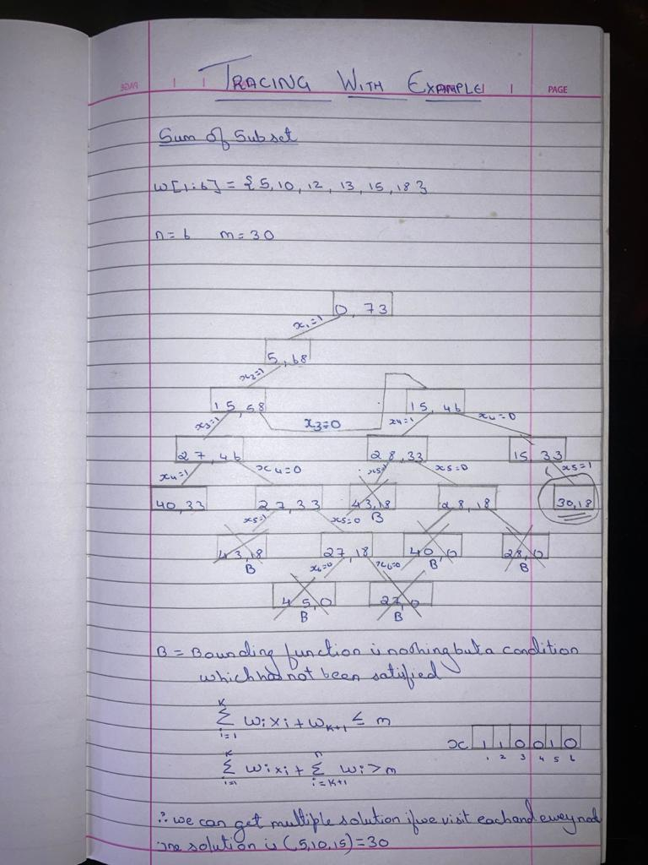

**Complexity**

* Worst case time complexity: ***Θ(2^n)***
* Space complexity: ***Θ(1)***

**Program**

#include<bits/stdc++.h>

using namespace std;

int c=0;

void SumofSub(int s,vector<int>,int k,int m );

void print(vector<int> ,int);

vector<int> v;

int a,sum;

int main()

{

int m=0,s=0,k=1;

cout<<"Enter The Value of N : "<<endl;

cin>>a;

v.resize(a+1,0);

vector<int> x;

x.resize(a+1,0);

cout<<"\nEnter The elements : "<<endl;

for(int i=1;i<=a;i++)

{

cin>>v[i];

m=m+v[i];

}

cout<<"\nEnter The sum : "<<endl;

cin>>sum;

for(int i=1;i<a;i++)

{

c++;

for(int j=i;j<=a;j++)

{

c++;

c++;

if(v[i]>v[j])

{

int temp = v[i];

v[i] = v[j];

v[j] = temp;

c=c+3;

}

}

c++;

}

c++;

SumofSub(s,x,k,m);

cout<<"***************"<<endl;

cout<<"Step Counts: "<<c<<endl;

cout<<"***************"<<endl;

}

void SumofSub(int s,vector<int> x,int k,int m )

{

c++;

if(k>a) return;

c++;

x[k] = 1;

c++;

if(s+v[k]==sum)

{

print(x,a);

}

else if(s+v[k]+v[k+1]<=sum)

{

c++;

SumofSub(s+v[k],x,k+1,m-v[k]);

}

c++;

if((s+m-v[k]>=sum)&&(s+v[k+1]<=sum))

{

c++;

x[k] = 0;

SumofSub(s,x,k+1,m-v[k]);

}

}

void print(vector<int> x,int a)

{

cout<<endl<<"--------------------------------------"<<endl;

for(int i=1;i<=a;i++)

{

c++;

c++;

cout<<x[i]<<" ";

}

cout<<endl<<"The elements ( ";

for(int i=1;i<=a;i++)

{

c++;

c++;

if(x[i]==1)

{

c++;

cout<<v[i]<<" ";

}

}

cout<<")";

cout<<endl<<"--------------------------------------"<<endl;

}

**Output**

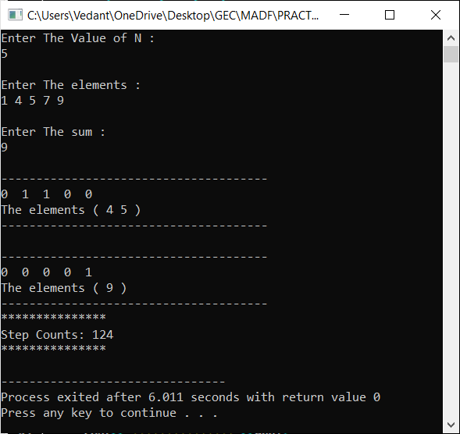

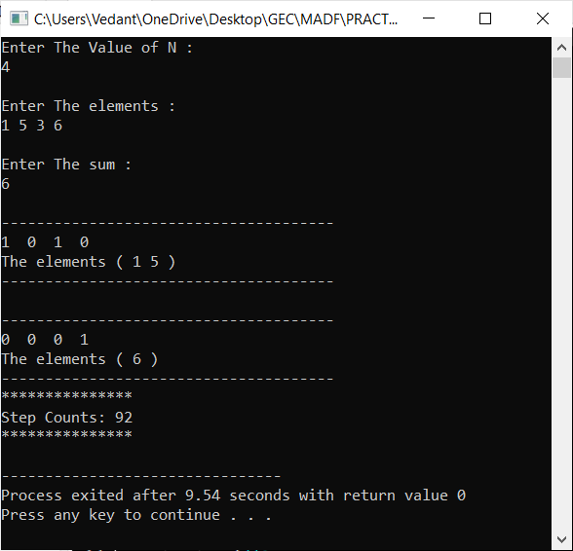

**Conclusion**

* Detailed concept of Sum of Subset problem (Using Backtracking) was studied successfully.
* Program using Sum of Subset Algorithm was executed successfully.
* The step count for the Sum of Subset Algorithm was obtained.